

MINOR PROJECT SYNOPSIS ON

Emotion Detection from Speech using Machine Learning

submitted in partial fulfilment of the requirements for the award of degree of

AMITY SCHOOL OF ENGINERING AND TECHNOLOGY

Submitted by: Supervised By:
Sukhman Arora Dr. Lokesh Pawar
A25305223154 Assisstant Professor
Amity University, Mohali

AMITY UNIVERSITY PUNJAB, MOHALI, INDIA

CONTENTS

Title Page No.
Abstract i
- Introduction 1
- Methodology 2
- System Architecture 7
- Tools and Technologies 8
- Project Plan 9
- Results and outcome 10
- Conclusion 11
- References

Abstract
Human speech is one of the richest forms of communication. Beyond conveying words, speech signals carry emotional tone, speaker identity, and conversational context. The automatic interpretation of these signals using artificial intelligence is a growing research area with applications across healthcare, education, customer service, and human-computer interaction.
This project presents the design and partial implementation of a Speech Emotion Detection and Speaker Identification system using machine learning techniques. The system uses the RAVDESS (Ryerson Audio-Visual Database of Emotional Speech and Song) dataset — a professionally recorded benchmark dataset containing 2452 speech recordings from 24 actors expressing 8 distinct emotions: neutral, calm, happy, sad, angry, fearful, disgusted, and surprised.
The system follows a five-stage pipeline: dataset collection and analysis, audio loading and visualization, audio preprocessing, feature extraction using Mel-Frequency Cepstral Coefficients (MFCC), and machine learning model training. At the current mid-term stage, the first four stages have been fully implemented and verified. All 2452 speech files have been preprocessed through amplitude normalization and silence trimming. A total of 40 MFCC coefficients have been extracted per audio file, producing a structured feature dataset of 2452 rows and 43 columns saved as mfcc_features.csv.
The planned completion of the project will include training machine learning classifiers such as Support Vector Machine (SVM) and Random Forest on the extracted features, building a speaker identification module using custom-recorded audio from local speakers, and generating a natural language output sentence describing the speaker and their emotional state.

- Introduction
Speech is the most natural and expressive form of human communication. When a person speaks, they convey far more than the literal meaning of their words. The tone, pitch, rhythm, and intensity of speech reveal the speaker's emotional state, level of confidence, and communication intent. For example, the same sentence "I am fine" can express happiness, sadness, sarcasm, or frustration depending entirely on how it is spoken.
The ability to automatically detect these emotional signals from speech audio is known as Speech Emotion Recognition (SER). SER systems analyze the acoustic properties of voice signals and map them to emotional categories. These systems have a wide range of practical applications. In healthcare, they can detect signs of depression or anxiety from patient speech. In customer service, they can identify frustrated callers and escalate calls automatically. In education technology, they can monitor student engagement and emotional state during online learning. Virtual assistants such as Siri and Alexa are also beginning to incorporate emotion-aware response systems.
Despite significant progress in recent years, speech emotion recognition remains a challenging problem. Emotions are subjective and vary across speakers, cultures, languages, and recording conditions. Most existing systems perform well on controlled laboratory datasets but struggle with real-world speech. Additionally, most systems focus only on emotion detection and do not simultaneously perform speaker identification.
This project addresses these challenges by building a system that combines emotion detection with speaker identification and speech type classification. The system is trained on the RAVDESS benchmark dataset and will be further enhanced using a custom-recorded dataset containing speech samples from local speakers including friends and teachers of the developer. The final system will produce a descriptive natural language sentence summarizing the speaker, their emotional state, and their speech type.
The motivation for this project comes from the growing need for emotionally intelligent AI systems. As voice interfaces become more common in daily life, the ability to understand not just what people say but how they say it becomes increasingly important. This project contributes a practical, reproducible implementation of such a system using widely available open-source tools.

- Methodology
The proposed system follows a five-stage pipeline to transform raw audio recordings into emotion and speaker predictions. Each stage is described in detail below.
- Dataset Collection and Analysis
The RAVDESS dataset was selected as the primary data source for this project due to its clean recording conditions, balanced emotion distribution, and well-documented file naming conventions. The dataset was downloaded and organized in the following folder structure:
Ravdess → Audio_Speech_Actors_01-24 → Actor_XX → [.wav files]
Each filename in the RAVDESS dataset encodes seven pieces of information separated by hyphens. For example, the filename 03-01-05-01-02-01-12.wav encodes: modality (03 = speech), vocal channel (01 = speech), emotion (05 = angry), emotional intensity (01 = normal), statement (02 = "dogs are sitting by the door"), repetition (01), and actor number (12). This naming convention was analyzed and implemented in code to programmatically extract emotion labels and actor identities from filenames without requiring a separate metadata file.
A dataset analysis script was written in Python to walk through all dataset folders, identify .wav files, and count speech versus song recordings. The analysis confirmed that the dataset contains 2452 speech recordings from 24 actors covering 8 emotion categories with the following distribution: neutral (188 files), calm (376), happy (376), sad (376), angry (376), fearful (376), disgust (192), and surprised (192). The slight imbalance between certain categories reflects the original RAVDESS recording design.
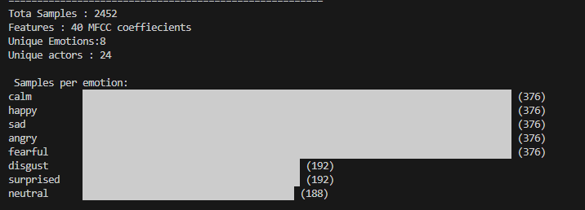
Fig 2.1 Dataset analysis output showing total speech files, emotion distribution across 24 actors
- Audio Loading and Visualization
Audio files were loaded using the Librosa library, a widely used Python package for audio and music signal analysis. The Librosa load function reads .wav files and returns the audio signal as a NumPy array along with the sample rate. All files were loaded at a standardized sample rate of 22050 Hz, which is the default sample rate used in Librosa and corresponds to the Nyquist frequency for human speech.
For each loaded audio file, the following properties were extracted and analyzed: sample rate (22050 Hz for all files), signal shape (number of samples), data type (float32), and duration in seconds. Waveforms were plotted using Matplotlib to visualize the time-domain representation of speech signals. These visualizations revealed clear differences in the amplitude patterns, rhythm, and energy distribution across different emotional states. For example, angry speech showed high energy throughout the recording, while calm speech showed lower and more uniform amplitude.
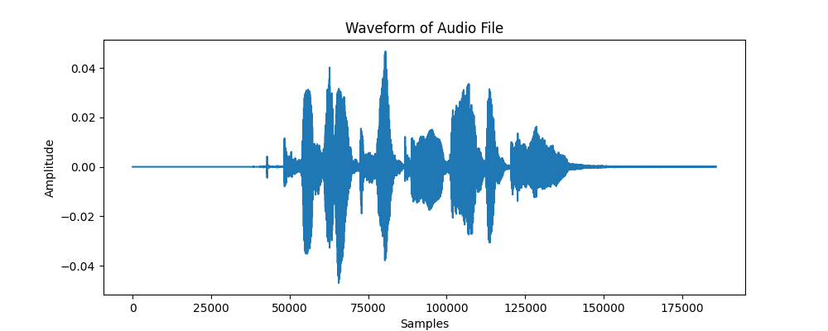
Figure 2.2 Waveform visualization of a speech recording loaded using Librosa
- Audio Preprocessing
Raw audio recordings vary in volume, duration, and the amount of silence at the beginning and end. These variations can introduce noise into the feature extraction process if not addressed. A preprocessing pipeline was implemented to standardize all recordings before feature extraction.
The preprocessing pipeline consists of three steps applied sequentially to every audio file.
- Audio Loading at Standard Sample Rate: Each .wav file is loaded at 22050 Hz using Librosa. Loading at a fixed sample rate ensures that all files are on the same temporal scale regardless of their original recording sample rate.
- Amplitude Normalization: The amplitude of each signal is normalized to the range [-1, 1] by dividing all sample values by the maximum absolute amplitude in the signal. This ensures that variations in recording volume across different actors, microphones, and sessions do not influence the feature extraction step. Without normalization, a loudly recorded angry utterance and a softly recorded angry utterance would produce different MFCC features even though they express the same emotion.
- Silence Trimming: Leading and trailing silence is removed from each recording using Librosa's trim function with a top_db threshold of 20 dB. This removes portions of the recording where the signal level is more than 20 dB below the peak level, which corresponds to silence or near-silence. Trimming reduces the total duration of each recording while retaining all speech content, which makes the subsequent feature extraction more focused on actual speech rather than silence.
The results of this preprocessing pipeline were verified by comparing the raw and trimmed signal lengths across all emotion categories. On average, silence trimming reduced signal length by 10–25%, with variations depending on the emotion expressed. Mel spectrograms were also generated to visually verify that preprocessing preserved the speech content while removing unwanted silence.
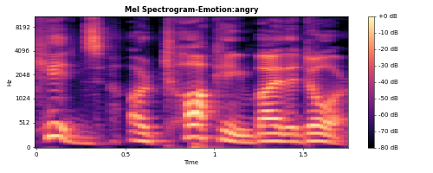
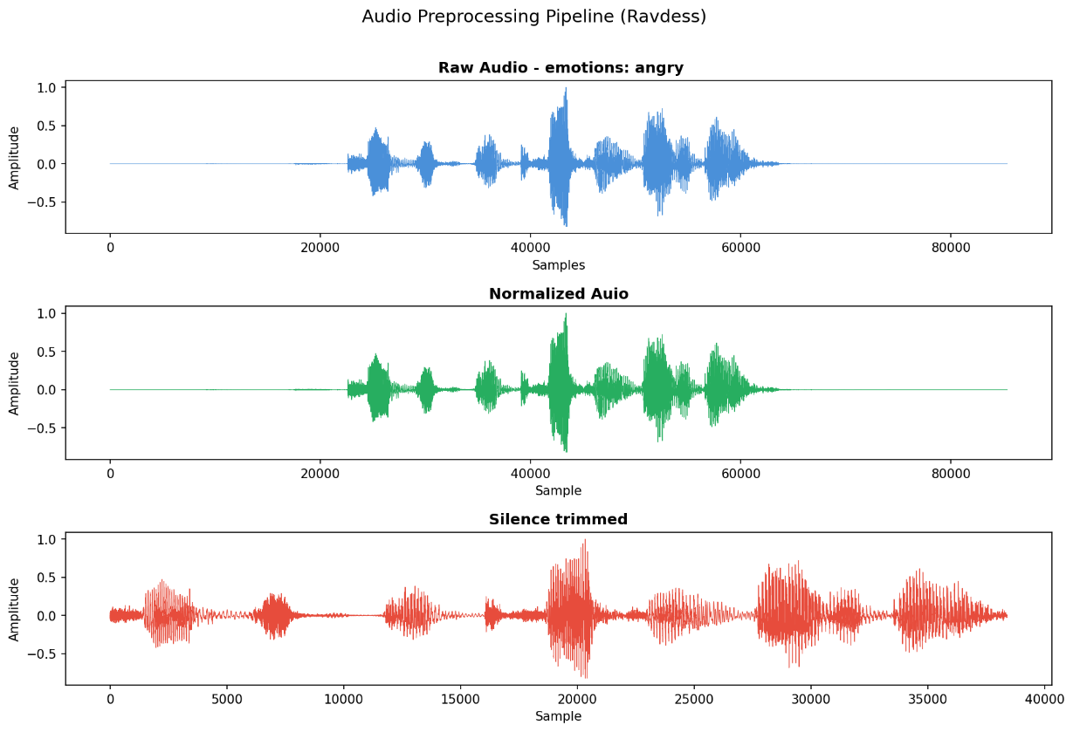
Figure 2.3 Three-stage audio preprocessing pipeline showing raw audio, normalized audio, and silence-trimmed audio
Figure 2.4 Mel spectrogram of a preprocessed speech recording showing frequency patterns over time
- MFCC Feature Extraction
Mel-Frequency Cepstral Coefficients (MFCC) are the core feature representation used in this project. MFCCs are a compact numerical representation of the spectral characteristics of speech that closely models how the human auditory system perceives sound.
The MFCC extraction process works as follows. The preprocessed audio signal is divided into short overlapping frames of approximately 25 milliseconds. For each frame, the Fast Fourier Transform (FFT) is computed to obtain the frequency spectrum. The spectrum is then mapped onto the mel scale, which is a perceptual scale that compresses high-frequency bins and expands low-frequency bins to match human hearing sensitivity. A filterbank of triangular filters is applied to the mel-scaled spectrum, and the logarithm of the filterbank energies is computed. Finally, the Discrete Cosine Transform (DCT) is applied to produce the final MFCC coefficients, which are decorrelated and compact representations of the spectral envelope.
For this project, 40 MFCC coefficients are extracted per audio file using Librosa's mfcc function. This produces a 2D array of shape (40, T) where T is the number of time frames. To produce a fixed-length feature vector suitable for machine learning, the mean value of each coefficient across all time frames is computed, collapsing the 2D array into a 1D vector of 40 values. This mean MFCC vector represents the average spectral characteristics of the entire speech recording.
The feature extraction was applied to all 2452 speech files in the RAVDESS dataset. The results were stored in a structured Pandas DataFrame with 40 MFCC feature columns, one emotion label column, one actor ID column, and one filename column, giving a total of 43 columns. This feature dataset was saved as mfcc_features.csv with 2452 rows, one per recording. This CSV file represents the complete numerical dataset that will be used for machine learning model training in the next phase of the project.
MFCC heatmap visualizations were generated for one sample file from each of the 8 emotion categories to visually verify that different emotions produce distinguishable MFCC patterns. These visualizations confirm that emotions such as angry and fearful produce markedly different coefficient distributions compared to neutral and calm speech, validating the effectiveness of MFCC as a discriminative feature for emotion classification.
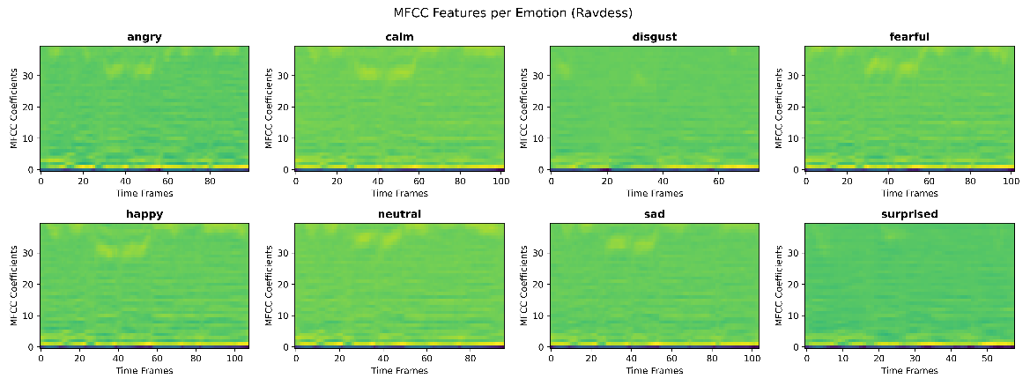
Figure 2.5 MFCC heatmaps for all 8 emotion categories showing distinct coefficient patterns per emotion
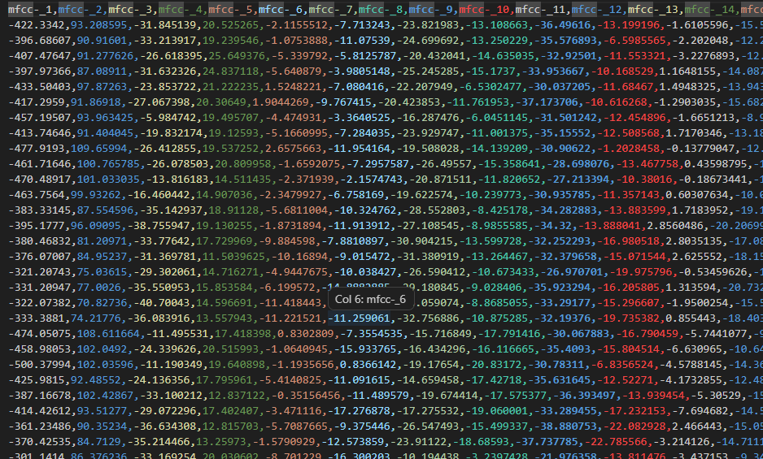
Figure 2.6 Extracted MFCC feature dataset (mfcc_features.csv) showing 40 coefficient columns, emotion labels, and actor IDs — 2452 rows total
- Machine Learning Model Training (Planned)
The next stage of the project, to be completed before the end-term evaluation, involves training machine learning classifiers on the extracted MFCC features.
The mfcc_features.csv dataset will be split into training and testing sets using an 80/20 split. Three classifiers will be trained and compared: Support Vector Machine with a radial basis function kernel, Random Forest with 100 estimators, and Logistic Regression as a baseline. All classifiers will be implemented using the Scikit-learn library.
Model performance will be evaluated using accuracy, precision, recall, F1 score, and a confusion matrix to understand which emotions are most and least accurately classified. The best-performing model will be selected for integration into the final prediction system.
In addition to the RAVDESS-trained model, a custom dataset will be recorded from local speakers and used to train a speaker identification module. The speaker identification module will use the same MFCC features to classify which speaker is talking in a given recording.

- System Architecture
The complete system architecture follows a linear pipeline from raw audio input to natural language output. The architecture is described below in sequential stages.
  - Audio Input: The system accepts a raw .wav audio file as input. This can be a file from the RAVDESS dataset for testing or a new recording from a custom speaker.
  - Preprocessing Module: The input audio is loaded at 22050 Hz, normalized in amplitude, and trimmed of silence using the preprocessing pipeline described in Section 2.3.
  - Feature Extraction Module: The preprocessed audio signal is passed to the MFCC extraction module, which computes 40 MFCC coefficients and returns a fixed-length feature vector of 40 values.
  - Emotion Classification Model: The 40-dimensional feature vector is passed to a trained SVM or Random Forest classifier, which outputs one of 8 emotion labels: neutral, calm, happy, sad, angry, fearful, disgust, or surprised.
  - Speaker Identification Model: The same feature vector is also passed to a speaker identification classifier, which outputs the name of the speaker from a predefined set of known speakers.
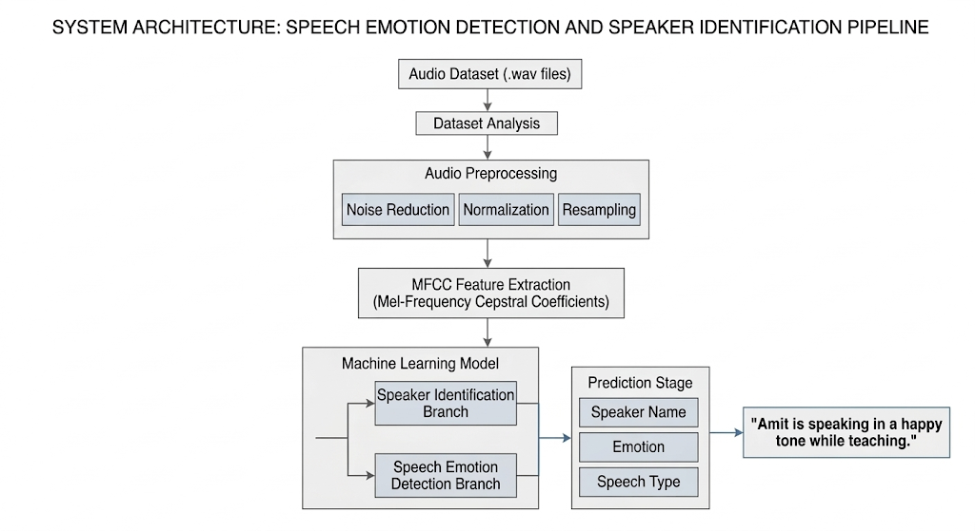
  - Output Generation: The predicted emotion label and speaker name are combined to generate a descriptive natural language output sentence. For example: "Amit is speaking in an angry tone." Or more detailed: "The speaker Rahul appears to be expressing sadness while sharing information."
Figure 3.1 System architecture diagram showing the complete pipeline from audio input to natural language output
- Tools and Technologies
Component | Tool / Library | Purpose
Programming Language | Python 3.x | Core development language
Audio Processing | Librosa 0.10 | Loading, preprocessing, MFCC extraction
Numerical Computation | NumPy | Array operations on audio signals
Data Visualization | Matplotlib | Waveform and spectrogram plots
Data Management | Pandas | Feature dataset creation and CSV export
Machine Learning | Scikit-learn | SVM, Random Forest, evaluation metrics
Audio Recording | SoundDevice + SoundFile | Custom dataset recording
Development Environment | Visual Studio Code | Code development and testing
Version Control | GitHub | Code repository and version management
Dataset | RAVDESS | Primary emotional speech benchmark dataset

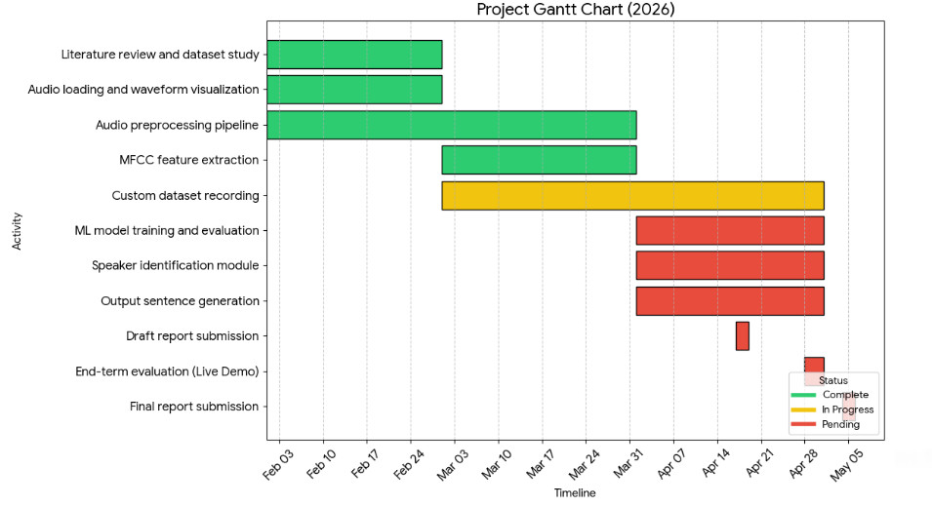
- Project Plan
Phase | Activity | Target Date | Status
Phase 1 | Literature review and dataset study | February 2026 | Complete
Phase 2 | Audio loading and waveform visualization | February 2026 | Complete
Phase 3 | Audio preprocessing pipeline | February–March 2026 | Complete
Phase 4 | MFCC feature extraction | March 2026 | Complete
Phase 5 | Custom dataset recording | March–April 2026 | In Progress
Phase 6 | ML model training and evaluation | April 2026 | Pending
Phase 7 | Speaker identification module | April 2026 | Pending
Phase 8 | Output sentence generation | April 2026 | Pending
Phase 9 | Draft report submission to supervisor | 17 April 2026 | Pending
Phase 10 | End-term evaluation with live demo | 28–30 April 2026 | Pending
Phase 11 | Final report hard binding submission | 4 May 2026 | Pending

- Results and Outcome
Upon completion of model training, the system is expected to produce the following outcomes.
Emotion Classification Accuracy: Based on published research using MFCC features with SVM classifiers on the RAVDESS dataset, an accuracy of approximately 65–75% is expected on the test set. Accuracy may vary across emotion categories, with highly distinct emotions such as angry and happy expected to show higher classification accuracy than more similar emotions such as calm and neutral.
Speaker Identification: The speaker identification module, trained on custom-recorded audio, is expected to correctly identify speakers from a small set of known individuals with high accuracy due to the relatively small number of speakers and controlled recording conditions.
Sample Output Sentences:
- "Amit is speaking in an angry tone."
- "Rahul appears to be expressing happiness while conversing."
- "The teacher is speaking in a calm and neutral tone while explaining a concept."
- "The speaker sounds fearful based on the detected speech patterns."
Generated Artifacts:
- mfcc_features.csv : complete feature dataset used for training
- preprocessing_steps.png : three-panel waveform comparison showing raw, normalized, and trimmed audio
- spectrogram.png : mel spectrogram of a sample speech recording
- mfcc_visualization.png : MFCC heatmaps for all 8 emotion categories

- Conclusion
This project presents a systematic approach to building a speech emotion detection and speaker identification system using machine learning. At the mid-term stage, a complete preprocessing and feature extraction pipeline has been successfully implemented and verified on the RAVDESS dataset. All 2452 speech files have been processed, and a structured feature dataset of 2452 rows and 40 MFCC features per sample has been generated and saved.
The work completed demonstrates a strong understanding of audio signal processing, feature engineering, and the RAVDESS dataset structure. The preprocessing pipeline ensures data consistency, and the MFCC feature visualizations confirm that emotionally distinct speech produces distinguishable coefficient patterns suitable for machine learning classification.
The remaining work involves training machine learning classifiers on the extracted features, building a speaker identification module using custom-recorded data, and developing the final output sentence generation system. These components will be completed and demonstrated at the end-term evaluation.
This project contributes a practical, reproducible implementation of speech emotion recognition that combines a standard benchmark dataset with custom local speaker data, making the system more applicable to real-world conversational speech scenarios.

- References

